The Cake

Supervisor. | Miss Esha shahid
Batch. | 2507G1
Group. | B
Serial No. | Enrollment Number | Student Name
1. | Student1674403 | Muhammad ahad shah
2. | Student1674467 | Muhammad umair
3. | Student1674875 | Muhammad aqib
4. | Student1673155 | Muhammad umar farooq

ACKNOWLEDGEMENT
Before anything, I would like to thank my beloved teacher Miss Esha Shahid who guided us throughout this project and helped us complete it within the limited time frame.
Secondly, I would like to express my gratitude to my team members Aqib, Ahad, Umair, and Umar for their cooperation and hard work in making this project successful.
Thirdly, I would also like to thank the institution for providing us with this wonderful opportunity to work on "The Cake" website project. Some of the key benefits we gained from this project are:
Reinforcement of web development skills through practical implementation
Enhanced understanding of responsive design and user experience
Improved teamwork and project management capabilities
Gained confidence to face real-world web development challenges

SYNOPSIS
With the help of modern web technologies, we have created "The Cake" - a premium cake ordering website that provides customers with a seamless online experience for exploring and purchasing delicious cakes.
Our website offers:
- Easy Online Ordering: Customers can conveniently browse through our cake catalog and place orders online
- Comprehensive Product Information: Detailed descriptions, prices, and high-quality images of all our cake varieties
- Event-Based Categorization: Cakes organized by occasions (Birthday, Anniversary, Wedding, etc.) for easy selection
- Responsive Design: Optimized viewing experience across all devices - desktop, tablet, and mobile
- User-Friendly Interface: Intuitive navigation and smooth ordering process

PROBLEM DEFINITION
To create an informative, interactive and business website for Cake manufacturers.
The brand name is “The Cake” and the shop is located all over the country. The
website has to be informative enough for the end users / viewers to know brief of
the various products and its prices and the availability.
You are supposed to create a website for them with the below mentioned
requirement specifications.
The website is to be developed for the Windows Platform using HTML5, JavaScript
and Geolocation. The site should work well in all leading browsers including Chrome, IE, Firefox etc.

CUSTOMER REQUIREMENT SPECIFICATION (CRS)

The website should cover the following links / pages:
1. Home page: The page should be designed with a banner at the top of the
page. The home page should cover a brief description of the entire website /
presentation as well as a brief history of cake.
2. About us: divide the page into three sections vertically. Provide the
foundation, mission and vision on these sections.
3. All products: the product page should be designed with all the products /
thumbnails along with brief details of the individual products, such as
- item code
- Price
- Egg less/with Egg
- order button
4. On click on the order button a purchase form page should appear on a new
browser window. The purchase form page should have all the form fields to
capture the entire transaction and the users&#39; details like
- Name
- Address
- Contact number
- Item code
- Quantity
- Delivery address
- Delivery Date

5. On click on the zoom button an enlarged image of the same product should
appear on a new browser window.
6. Products by event: provide a categorized sub-navigation on this page such
as
- Birthday
- Anniversary
- Engagement
- Marriage and so on.

Each and every sub-navigational button should be linked to an individual page. All
the individual page should be designed with selected / categorized thumbnails along
with brief details of the individual products, such as item code, price, zoom and order
button.
7. On click on the order button a purchase form page should appear on a new
browser window. The purchase form page should have all the form fields to
capture the entire transaction and the users’ details.
- Name
- Address
- Contact number
- Item code
- Quantity
- Delivery address
- Delivery Date
8. On click on the zoom button an enlarged image of the same product should
appear on a new browser window.
9. Site Map: The site map page should contain the entire navigational structure
/ diagram in a visual form and all the links (page names) of the diagram
should be programmed for hyperlink to the respective pages.
10. About us, Contact Us, Disclaimer must be included. “Contact Us” page should
have the Address of the Company and the mail address which when clicked
will invoke the local mail client from where they can send an email. Address
of the Company should be displayed using GeoLocation API (eg. GoogleMaps)
11. Creating an account facility can also be added.
12. Dummy procedure for buying to be added..

SCOPE OF THE WORK (IN BRIEF)
The website is to be developed for the Windows Platform using HTML5, JavaScript and bootstrap jQuery. The site should work well in all leading browsers including Chrome, Firefox etc. Our welcome page icon is re-directed to the main web page Ever essential content direct to relative content.
AGGREGATED SITEMAP
THE CAKE WEBSITE :
├── 🏠 HOME PAGE
│ ├── Welcome Banner
│ ├── About Cakes Section
│ └── 5-Step Buying Process
│
├── ℹ️ ABOUT US
│ ├── Foundation
│ ├── Mission
│ └── Vision
│
├── 🎂 ALL PRODUCTS
│ ├── Chocolate Delight (CD001)
│ ├── Vanilla Dream (VD002)
│ ├── Red Velvet (RV003)
│ ├── Lemon Zest (LZ004)
│ └── Floral Chocolate Cake (FPC005)
│
├── 🎉 PRODUCTS BY EVENT
│ ├── 🎂 BIRTHDAY CAKES
│ │ ├── Chocolate Birthday Cake
│ │ ├── Rainbow Birthday Cake
│ │ └── Vanilla Birthday Cake
│ │
│ ├── 💖 ANNIVERSARY CAKES
│ │ ├── Golden Anniversary Cake
│ │ ├── Heart Anniversary Cake
│ │ └── Floral Anniversary Cake
│ │
│ ├── 💍 ENGAGEMENT CAKES
│ │ ├── Diamond Ring Cake
│ │ ├── Rose Engagement Cake
│ │ └── White Engagement Cake
│ │
│ └── 💒 MARRIAGE CAKES
│ ├── Royal Wedding Cake
│ ├── Floral Wedding Cake
│ └── Elegant Wedding Cake
│
├── 🔐 CREATE ACCOUNT / LOGIN
│ ├── Login Form
│ ├── Create Account Form
│ ├── Forgot Password
│ └── Social Media Login
│
├── 📞 CONTACT US
│ ├── Location Map
│ ├── Contact Form
│ ├── Store Hours
│ └── Social Media Links
│
└── ⚖️ LEGAL PAGES
├── Disclaimer
├── Privacy Policy
└── Terms of Service

Screenshots:
Login page
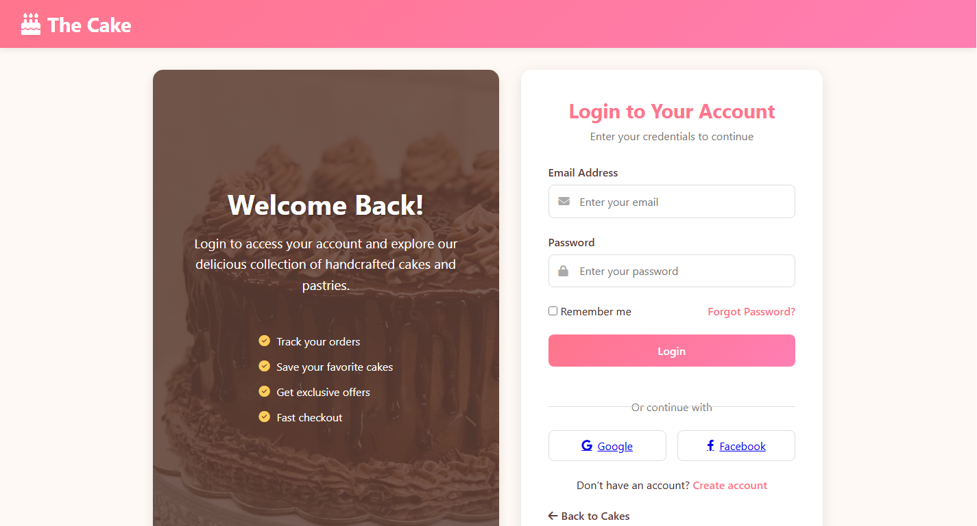


6 eProject: The Cake

Home page
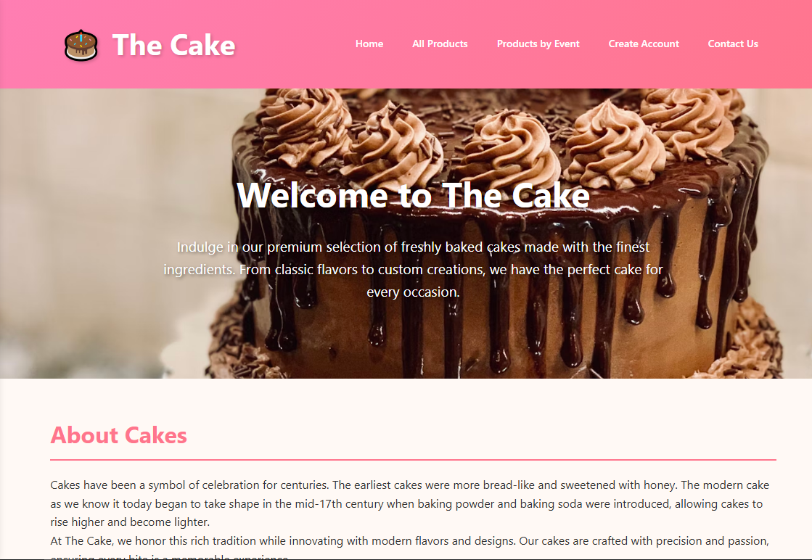
ALL PRODUCT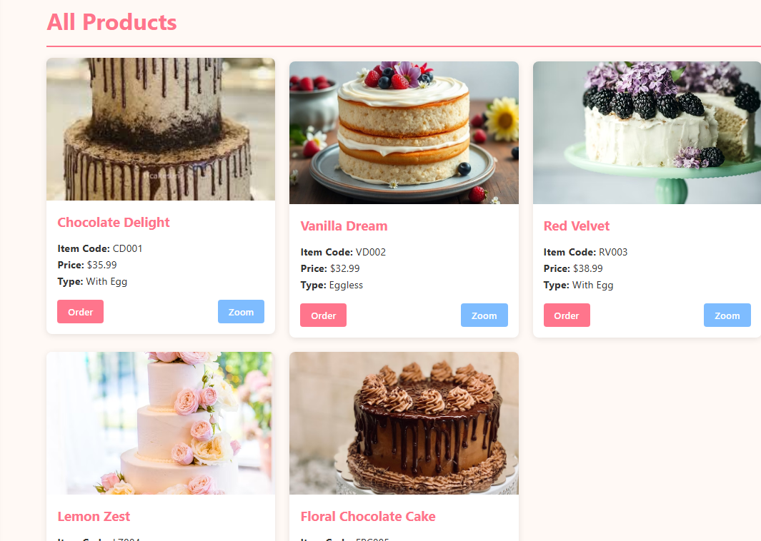

Product by event:
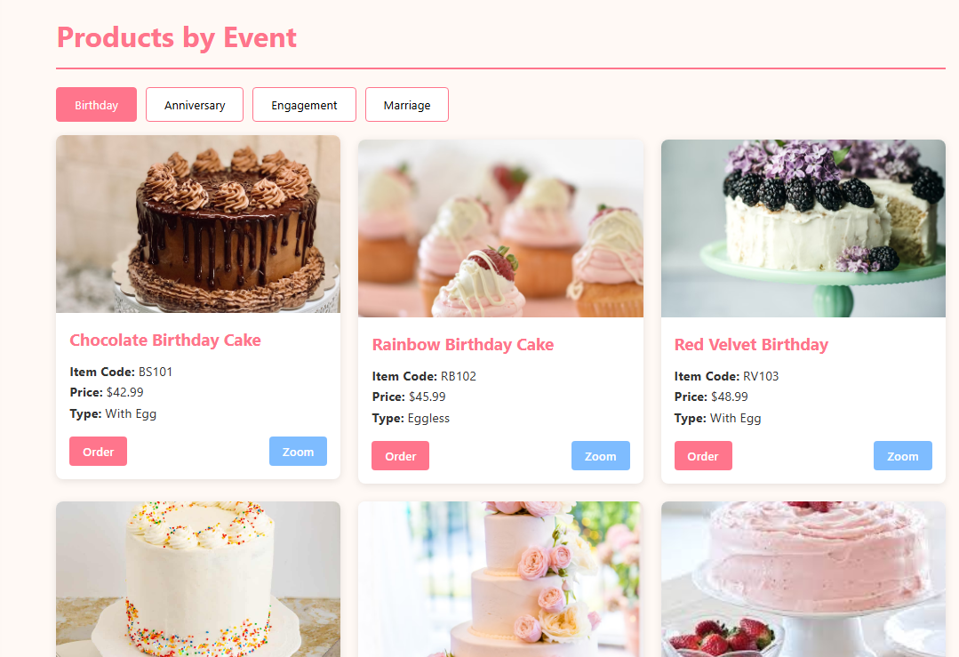
Contact us :
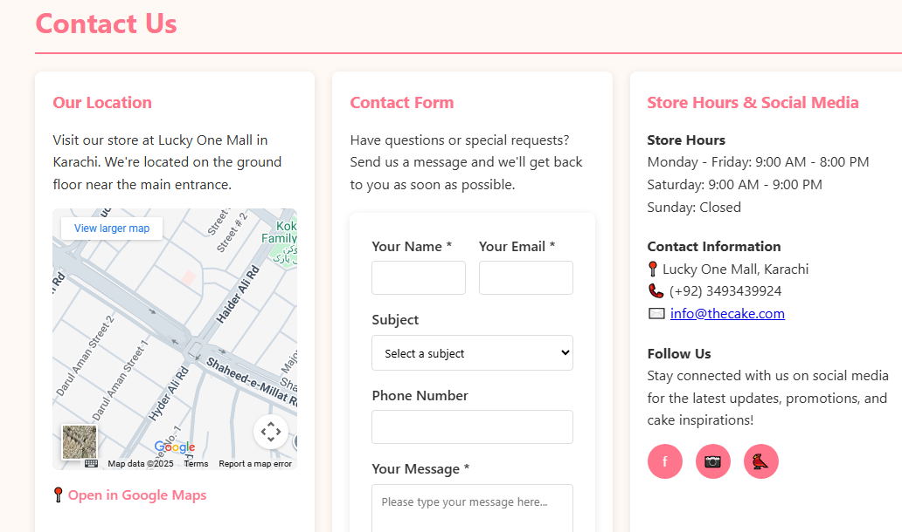

Footer:
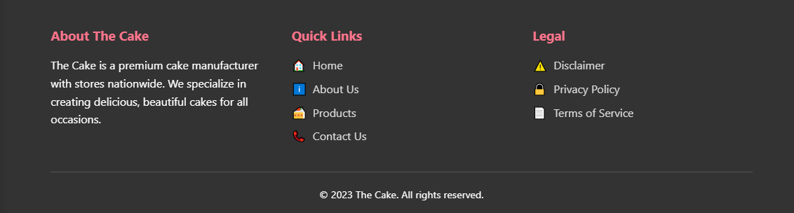

Site map:
